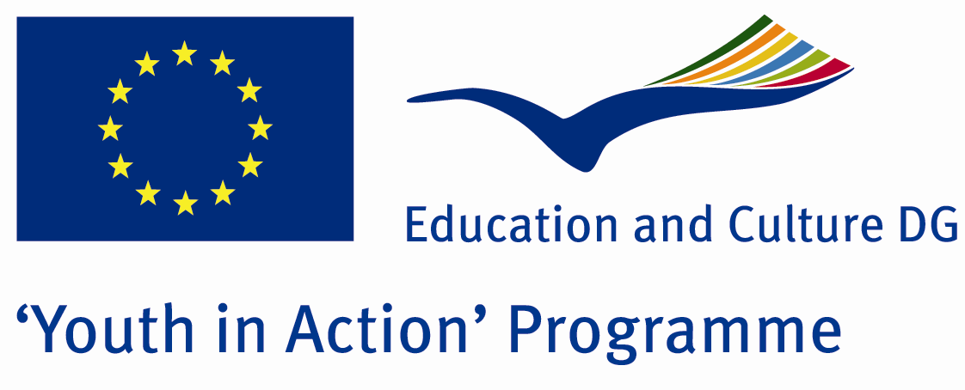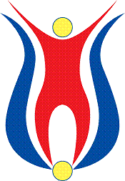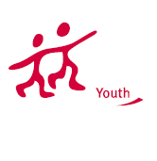

Symbols of the Countries
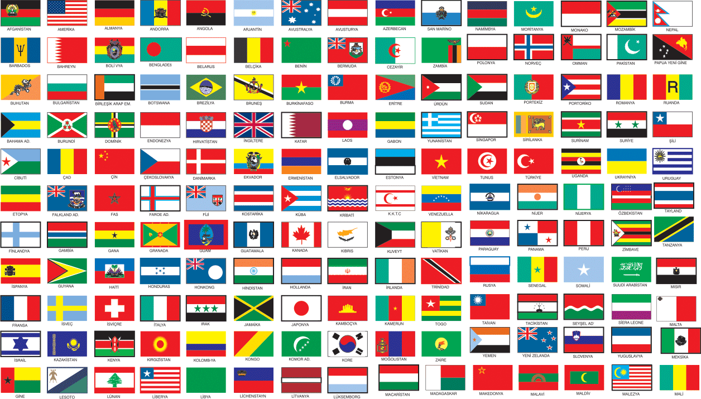

ACTION 1.1 – Youth Exchange

19-26th September, 2011

Sakarya, TURKEY

ACTION 1.1 - Youth Exchange
19-26th September, 2011
Sakarya, TURKEY

Please contact directly to;
adventurerpeacepigeons@gmail.com

Project Summary;

There are 203 countries in the world and International well-known in 193 countries. And all of countries have an athems. Our country’s flag and anthem have an impressive story, therefore, we want to know the stories of other countries flag and national anthem. And decided to do this Project.

If you want to join this project, please contact us..

Project Title; Flags and National Anthems

Date and Venue ; 19-26th September, 2011 Sakarya, Turkey .

Target Group ; Municipalities, City Councils and Non-Governmental organizations,
youth groups,culture and art groups,e.t.c

Participants ; 5 people from each country (over 18 -25 ). Totally 8 countries.

Conditions ; Accommodation, board and programme costs will be financed through European Commission Youth in Action Programme (Action 4.3). Travel costs will be reimbursed in 70% (APEX Tarrifs). Organizations from all 27 EU member countries plus Liechtenstein , Norway and Iceland are eligible to take part.

Working language: English

Organizer; Adventurer Peace Pigeons

How to apply: If you are interested, please send your Part III forms to
by e-mail please (in word file). Scan Part3 format is enough for application.(Fulfilled Part III which you can find in the attachment, of course signed and stamped) ..

Next step 2;
Original send via regular post to this address please:

Ertan DERİN
Fevzi Çakmak Mahallesi Tuncer Sokak No:6 PENDİK/İSTANBUL/TÜRKİYE
e-mail : adventurerpeacepigeons@gmail.com
Mobile : 0090 542 393 93 90

If you have any questions you may contact with: adventurerpeacepigeons@gmail.com
Deadline: 15th May 2011

For Further information:
Contact Person
Ertan DERİN
Fevzi Çakmak Mahallesi Tuncer Sokak No:6 PENDİK/İSTANBUL/TÜRKİYE
e-mail : adventurerpeacepigeons@gmail.com
Mobile : 0090 542 393 93 90

